ARP Entries – Dynamic

🧱 What Is ARP Entries – Dynamic?
# Source: Chatgpt (GPT‑5 Mini) at [12/14/2025]
A dynamic ARP entry is an IP-to-MAC mapping that is automatically learned by a device when it sends or receives an ARP request or ARP reply on a network.

🔁 What Are ARP Request and ARP Reply?
# Source: Chatgpt (GPT‑5 Mini) at [12/14/2025]
ARP (Address Resolution Protocol) is used to map an IP address to a MAC address on a local area network (LAN). This is essential for enabling devices to communicate over Ethernet or Wi-Fi.

📡 What is an ARP Request?
# Source: Chatgpt (GPT‑5 Mini) at [12/14/2025]
An ARP request is a broadcast message sent by a device that wants to know the MAC address of another device using its IP address.
🧠 It asks:
👉 “Who has IP address 192.168.1.5? Tell me your MAC!”
✅ Key Points:
- Sent as a broadcast to all devices on the LAN.
- The source includes its own IP and MAC in the request.
- Only the device with the matching IP address responds.

📬 What is an ARP Reply?
# Source: Chatgpt (GPT‑5 Mini) at [12/14/2025]
An ARP reply is a unicast message sent in response to an ARP request. It provides the MAC address associated with the requested IP address.
🧠 It answers:
👉 “I have IP 192.168.1.5. My MAC is AA:BB:CC:DD:EE:FF.”
✅ Key Points:
- Sent directly (unicast) to the requester.
- Includes the MAC and IP of the responding device.
- The requesting device updates its ARP table with this info.

🔄 ARP Workflow Example
# Source: Chatgpt (GPT‑5 Mini) at [12/14/2025]
Device A (IP: 192.168.1.10, MAC: 11:22:33:44:55:66)
wants to send data to Device B (IP: 192.168.1.20).

1️⃣ Device A sends ARP Request (broadcast):
# Source: Chatgpt (GPT‑5 Mini) at [12/14/2025]
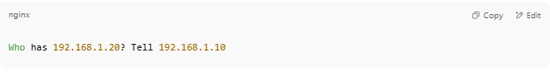
Who has 192.168.1.20? Tell 192.168.1.10

2️⃣ Device B replies (unicast):
# Source: Chatgpt (GPT‑5 Mini) at [12/14/2025]
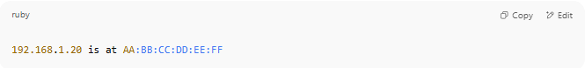
192.168.1.20 is at AA:BB:CC:DD:EE:FF

3️⃣ Device A updates ARP Table:
# Source: Chatgpt (GPT‑5 Mini) at [12/14/2025]
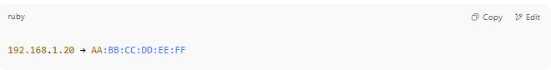
192.168.1.20 → AA:BB:CC:DD:EE:FF

Now it can send Ethernet frames directly to that MAC.

📦 Visual Representation
# Source: Chatgpt (GPT‑5 Mini) at [12/14/2025]

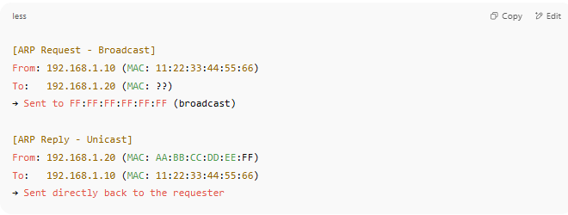
[ARP Request - Broadcast]
From: 192.168.1.10 (MAC: 11:22:33:44:55:66)
To: 192.168.1.20 (MAC: ??)
→ Sent to FF:FF:FF:FF:FF:FF (broadcast)

[ARP Reply - Unicast]
From: 192.168.1.20 (MAC: AA:BB:CC:DD:EE:FF)
To: 192.168.1.10 (MAC: 11:22:33:44:55:66)
→ Sent directly back to the requester

✅ Summary
# Source: Chatgpt (GPT‑5 Mini) at [12/14/2025]
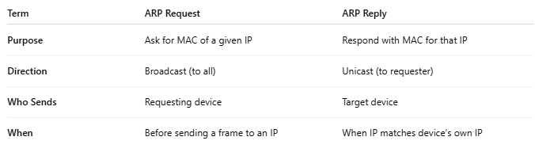
Term | ARP Request | ARP Reply
Purpose | Ask for MAC of a given IP | Respond with MAC for that IP
Direction | Broadcast (to all) | Unicast (to requester)
Who Sends | Requesting device | Target device
When | Before sending a frame to an IP | When IP matches device’s own IP

🧠 Simple Definition:
# Source: Chatgpt (GPT‑5 Mini) at [12/14/2025]
A dynamic ARP entry is added to the ARP table automatically when a device learns a neighbor’s MAC address via normal ARP communication.

📥 How It’s Created:
# Source: Chatgpt (GPT‑5 Mini) at [12/14/2025]
- Your device wants to talk to 192.168.1.10, but doesn’t know its MAC.
- It sends a broadcast ARP request:
"Who has 192.168.1.10?"
- The device with that IP replies with its MAC address.
- Your device adds a dynamic entry to the ARP table.

📋 Example: Dynamic ARP Entry
# Source: Chatgpt (GPT‑5 Mini) at [12/14/2025]
IP Address | MAC Address | Interface | Type
192.168.1.10 | AA:BB:CC:DD:EE:FF | eth0 | Dynamic
On Linux:
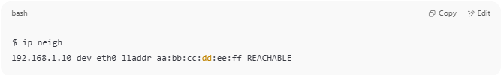
$ ip neigh
192.168.1.10 dev eth0 lladdr aa:bb:cc:dd:ee:ff REACHABLE

On Windows:
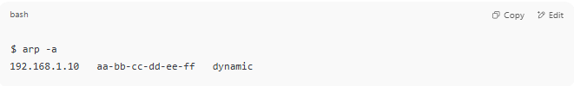
$ arp -a
192.168.1.10 aa-bb-cc-dd-ee-ff dynamic

🔁 Behavior of Dynamic Entries:
# Source: Chatgpt (GPT‑5 Mini) at [12/14/2025]
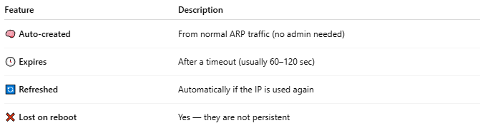
Feature | Description
🧠 Auto-created | From normal ARP traffic (no admin needed)
🕓 Expires | After a timeout (usually 60–120 sec)
🔄 Refreshed | Automatically if the IP is used again
❌ Lost on reboot | Yes — they are not persistent

✅ Summary
# Source: Chatgpt (GPT‑5 Mini) at [12/14/2025]
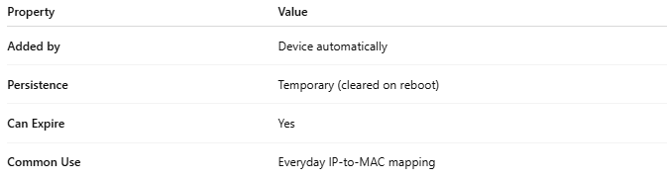

Property | Value
Added by | Device automatically
Persistence | Temporary (cleared on reboot)
Can Expire | Yes
Common Use | Everyday IP-to-MAC mapping

